
Document BRD
This specification outlines V Mobile’s business requirements for subscriber behaviour analysis in relation to a recently launched campaign.

Business Requirements Document
Subscriber Behaviour Analysis for Campaigns

PBT Academy
Issue 0.001, Author Control
October 2025
Copyright
Copyright © 2019 PBT Group (SA) (Pty) Ltd.)
All rights reserved. Company and product names are trademarks or registered trademarks of their respective companies

Contents
1. Project Introduction 3
1.1 Scope 3
1.2 Business Problem 3
1.2.1 Qualification Criteria 3
1.2.2 Assumptions 3
1.2.3 Business Rules 3
2. Project Solution 4
2.1 Data Analysis 4
2.1.1 Data Flow diagram 4
2.1.2 Solution Diagram 4
2.2 Data Preparation 4
2.3 Data Visualisation 4
2.3.1 Visualisation 4
2.4 Client Presentation 4
2.5 Technology 4

Project Introduction
The marketing team at V Mobile is launching a campaign to give free minutes to valuable members. However, they are functioning without visibility, which is a vital instrument. They don't have a dependable, automatic method to find out how many customers are eligible for the campaign each week, how much money they make overall, or how they use the network. They are unable to gauge campaign success, improve their approach, and prove return on investment because of this "flying blind" approach. This project was initiated to bridge that gap by building a data-driven reporting solution from the ground up.

Scope
Project Name | V Mobile Campaign Performance Reporting
Client/Supervisor + email | V Mobile Marketing Department, academy@pbtgroup.co.za
Date | 08/10/2025
Team | Eddie Mjiyakho
Overall purpose and stakeholders | The purpose of this project is to address V Mobile Marketing's inability to see the effectiveness of their "free minutes" campaign. Marketing is currently unable to assess the revenue and usage trends of their subscribers, as well as track the number of members who qualify for the campaign each week. In order to convey these insights and facilitate data-driven campaign decisions, my project will produce an interactive dashboard and an automatic weekly report.  - V Mobile Marketing Department is the primary client who will use the reports and dashboard for weekly operations and strategic planning.  - The Data Engineering/IT Team will be responsible for maintaining the data pipelines and solutions I build.  - Business Executives who are interested in the high-level trends and ROI of the marketing campaign.
SMART Goals | Functions and Features:  - Qualifying subscribers and their contributions are clearly displayed in a weekly automatic report.  - An interactive dashboard that lets marketing teams investigate regional performance and trends.  - A single subscriber master list that complies with corporate regulations and eliminates duplication.  - Actionable insights that can be used to enhance subscriber engagement and campaign performance.  Goal 1: Unified Subscriber Master List  - Specific: Utilizing established business rules, merge all subscriber data from the three source systems (V Mobile, BlueMobile, and ArrowMobile) into a single, de-duplicated database.  - Measurable: Each distinct cell number has a clear Is Master Record flag in a single SQL table or DataFrame.  - Achievable: Python (Pandas) or SQL can be used to accomplish this common data consolidation task.  - Relevant: This ensures that each subscriber is counted just once and serves as the basis for all accurate reporting.  - Time-bound: This will be the first deliverable in the data preparation stage.  Goal 2: Automated Weekly Qualification Report  - Specific: Generate a report every Monday that includes the overall revenue, SMS count, and voice call count of all subscribers who qualified (revenue ≥ R30) during the previous week.  - Measurable: Every week, an automatically generated report (such as a CSV, PDF, or email) with the necessary columns and the appropriate date format (yyyymmdd) is generated.  - Achievable: A scheduled Python script or SQL stored procedure that handles the weekly use data extract can make this automatic.  - Relevant: This directly addresses the core business problem of tracking campaign performance.  - Time-bound: This will be the core output of the project's reporting layer.  Goal 3: Interactive Trend Analysis Dashboard  - Specific: Create a Power BI dashboard that enables Marketing to interactively examine historical patterns in the quantity of qualified subscribers and their geographic distribution.  - Measurable: A Power BI report that has been published and includes at least two primary visuals, such as a map or chart for geographic analysis and a time-series chart for qualification patterns.  - Achievable: Power BI can easily connect to the prepared data to create these visualizations.  - Relevant: This provides the deep analytical insight needed to understand "why" behind the weekly numbers.  - Time-bound: This will be the final deliverable for the data visualization stage.
Inputs, outputs, and performance
  Input | Performance | Output
  Raw subscriber data from 3 source systems (VMobile, BlueMobile, ArrowMobile). | The consolidation script should run efficiently, correctly applying business rules to resolve duplicates. | A single, clean Subscriber Master Table.
  Weekly usage records from the Mediation system (usage_records, usage_records_week_2, etc.). | The weekly report must be generated and delivered shortly after the Monday 04:00 data extract, ensuring data is fresh for Marketing. | An automated Weekly Qualification Report (e.g., CSV file).
  Subscriber Master Table & Weekly Usage Data. | The Power BI dashboard must load and refresh interactively, allowing users to filter and drill down into the data without long delays. | An Interactive Power BI Dashboard for trend and regional analysis.
Resources and Constraints | Resources needed:  SQL Server/Python for data processing, Power BI for visualization, access to the source data files.  Limitations and Challenges:  - Data Consistency: Careful mapping is necessary since subscriber data originates from three distinct systems with disparate column names and formats (e.g., CellNo vs. Cell vs. Cell Number, SIMDate vs. Activate).  - Logic Complexity: The master record's business rules are multi-step and require exact implementation.  - Location Mapping: The usage data only contains a CITY_ID, requiring a join to the city_lookup table to get meaningful regional insights for the dashboard.
Feasibility | The project is highly feasible. The necessary technology (SQL, Python, and Power BI) is appropriate for the job, and the data supplied is clean and complete. The primary challenge is the precise implementation of the data consolidation business logic, which is a controllable and clearly stated issue.

Business Problem
Background Story:
As part of a promotion, V Mobile is giving away free minutes to customers who make at least R30 a week from voice or SMS calls. The organisation's subscriber source and mediation systems provide clean, reliable data, but this data is nonetheless isolated and unprocessed. Marketing is losing out on a big chance to use this data for strategic decision making since it does not have a unified view of subscriber data or an automated method to gauge campaign performance.

Main Issue:
The marketing division is unable to monitor the number of subscribers who are eligible for the weekly free minute promotion, nor is it able to examine the income contribution or usage patterns of these valuable subscribers. They're essentially "flying blind" in terms of tracking campaign performance.

Consequences:
There are immediate negative effects from this lack of visibility.
- Ineffective campaign management results from marketing's inability to assess the campaign's success or calculate its Return on Investment (ROI).
- The team cannot effectively allocate resources or optimize campaign targeting without trends and regional analysis, which results in inadequate strategic choices.
- V Mobile loses out on opportunities since it is unable to recognize and comprehend qualifying users, which keeps them from participating in loyalty programs or follow-up offers.

Business Need:
V Mobile needs a reliable, automated solution that provides a single source of truth for subscriber data and delivers timely, actionable insights into weekly campaign performance, enabling the Marketing team to monitor, analyse, and optimize their promotional activities.

Proposed Solution (High-Level):
I will build a centralized data pipeline that consolidates all subscriber records according to business rules and automatically processes weekly usage data. This will feed both an operational report for weekly tracking and an interactive dashboard for deep-dive analysis into qualification trends and geographic performance.

Expected Outcomes:
The following criteria will be used to gauge success.
- Every Monday, an automated weekly report is delivered that includes the total revenue, SMS count, voice call count, and list of all eligible customers.
- The "how many?" and "where?" questions about campaign performance can be independently answered by marketing using an interactive Power BI dashboard.
- Creation of a dependable Subscriber Master Table that removes confusion and duplication from several source systems.
- Provide insights that can be used to enhance subscriber engagement and campaign performance.

Qualification Criteria

Data preparation criteria required to determine the master record and qualifying subscriber:
- A subscriber qualifies for the campaign in a given week if: SUM(USAGE_EVENT_REVENUE for that subscriber from Monday 00:00:00 to Sunday 23:59:59) >= 30, then that subscriber is eligible for the campaign in that particular week.
- The VMobile_usage_records table and later weekly files such as week_2 are the data source.
- Free calls have been removed from the data collection, according to the case study. All of the revenue in the USAGE_EVENT_REVENUE column is therefore billable and contributes to the R30 level.

Assumptions

These are the assumptions used in the project.
- The data is complete and clean. I assume the provided usage records (VMobile_usage_records.csv, WMobile_usage_records_week_2.csv) cover a full week (Monday to Sunday) and contain all billable SMS and voice call events, as per the case study.
- I assume the USAGE_EVENT_REVENUE column in the usage records provides the final, correct amount to be summed for the qualification criteria. No further calculations are needed for revenue calculation.
- I assume date format consistency for all the date records.
- I assume the USAGE_EVENT_CITY_ID in the usage records correctly corresponds to the CITY_ID in the VMobile_city_lookup table to get the city and province names for the regional analysis.
- I assume the Cell Number/CellNo/Cell field is the unique identifier (MSISDN) for a subscriber across all systems, which is used to link usage records to subscriber details and provides subscriber uniqueness.

Business Rules

The business has established certain non-negotiable rules for data preparation.
- Consolidation Rule for Master Records (for the unified subscriber table) to eliminate duplicates from the three source systems (VMobile_subscribers, VMobile_subscribers_bluemobile, and VMobile_subscribers_arrowmobile).
- Rule 1 (Highest Priority): If a subscriber (by Cell Phone Number) exists in the VMobile system, that record is always the master record. (Is Master Record = True for this VMobile record.)
- Rule 2 (Secondary Priority): If a subscriber does not exist in VMobile, but exists in BlueMobile and/or ArrowMobile, compare the SIM Activation Date. Then the record with the most recent (MAX) SIM Activation Date becomes the master record.
- Rule 3 (Tie-Breaker): If there is a tie for the most recent SIM Activation Date between BlueMobile and ArrowMobile, the record from BlueMobile takes priority.
- Campaign Qualification Rule: As defined in the "Qualification Criteria" above, a subscriber qualifies based on a sum of weekly revenue must be great or equal R30.
- Data Source Trust Rule: V Mobile is the most trusted source for subscriber information. This is the foundational rule for the master record logic.

Project Solution
My solution introduces a robust, automated data pipeline that transforms raw, dispersed data into actionable business intelligence. Using V Mobile's unique business rules, I started by resolving the fundamental data quality issue by combining three distinct subscriber systems into a Single Source of Truth. This clean, master subscriber list then becomes the anchor point. The system automatically examines millions of call and SMS records every week, determines each subscriber's total earnings, and finds all users who reach the R30 qualifying criteria. The result is a clear, concise Weekly Report that is delivered directly to Marketing. I have created an Interactive Power BI Dashboard in addition to this operational report, which enables the marketing team to go beyond "what happened" and comprehend "why it happened." They can now explore trends over time and pinpoint which geographic regions are responding best to the campaign, enabling truly data-driven decision-making.

Data Analysis
The knowledge I acquired by examining the project specifications and the supplied data files is described in this part.
- Subscribers who earn at least R30 per week from voice or SMS calls are eligible to receive free minutes as part of the program. Data usage and other events contribute to revenue but are not the focus of the campaign. Free calls are already excluded from the source data.
- Transactional level usage data is available. A single event (such as a single call or SMS bundle) is represented by each row. For weekly analysis, this calls for aggregation (counting events, adding up income) at the subscriber level.
- The universal key for connecting usage records to subscriber information and locating duplicates across the three source systems that provide subscriber identity is the Cell Phone Number (MSISDN).
- Every analysis is completed every week, Monday through Sunday. The scope is temporary because the reporting date is the Monday when the data is processed.
- The subscriber data structure is unchangeable: BlueMobile over ArrowMobile under V Mobile > Most Recent SIM Date. This is derived from the logic of the master record and guarantees that each subscriber receives a single version of the truth.

Data Flow diagram

The following Data Flow Diagram (DFD), rendered in the Gane and Sarson level zero notation, illustrates the detailed movement and processing of data within the V Mobile data pipeline. The purpose of this diagram is to show how data is taken out of source systems, converted using particular business rules, stored, and then sent to end users in an understandable and rational manner. Developers and analysts can better grasp the particular processes, data storage, and external entities involved by using the DFD, which was chosen for its formalism and clarity in mapping data transformations. It highlights the data flows between the pipeline's distinct, manageable processes, like weekly aggregation and subscriber consolidation. This granular view simplifies the comprehension of a potentially complex ETL (Extract, Transform, Load) workflow, ensuring all stakeholders have a precise understanding of the data's journey and supporting the project's goals of data integration and accurate reporting.

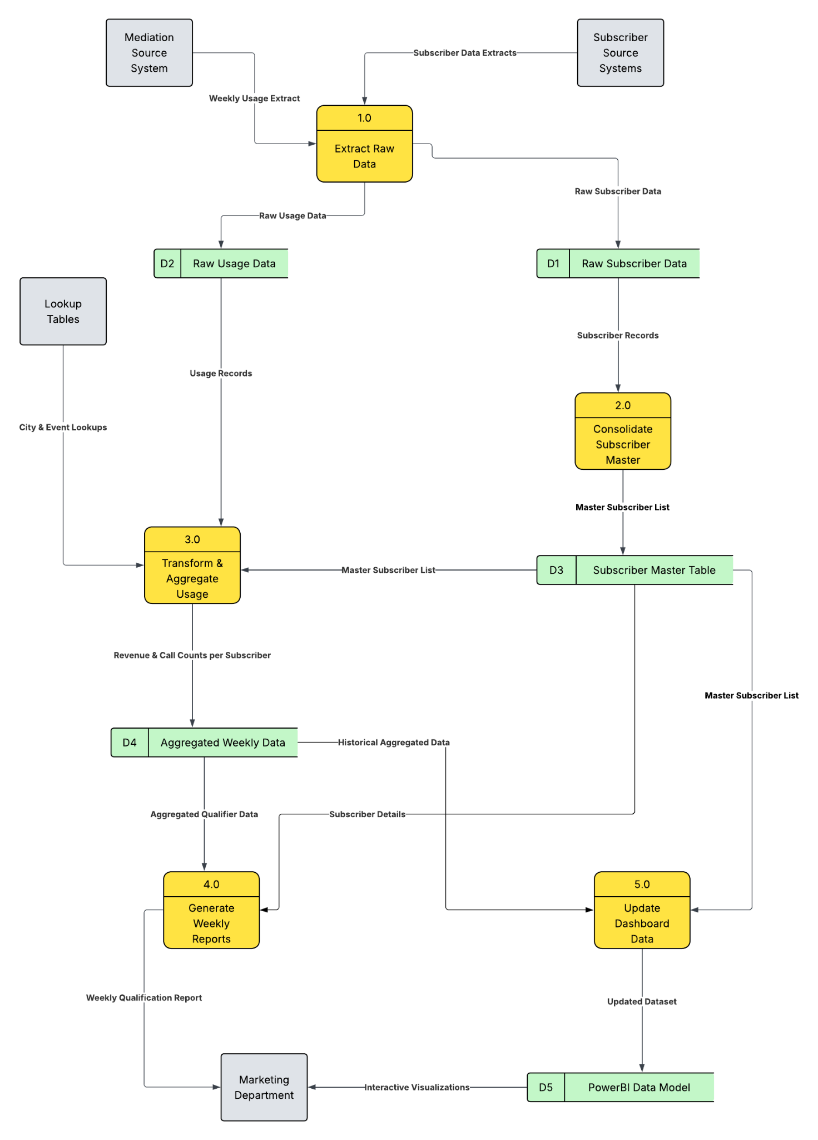

Solution Diagram

The V Mobile Campaign Performance Reporting system's technical elements and their interconnections are conceptually summarized in the Solution Architecture Diagram that follows. From data sources to the final business intelligence deliverables, this diagram is intended to show the solution's whole structure. It does a good job of showing how the layers of data preparation, storage, and visualization are separated from one another. Both technical and business stakeholders may easily understand the overall system design and the data flow between important technologies, such as Python/SQL for processing and Power BI for reporting. Aligning the technical implementation with the overarching business goals of automation, insight generation, and data-driven decision-making requires this high-level perspective.

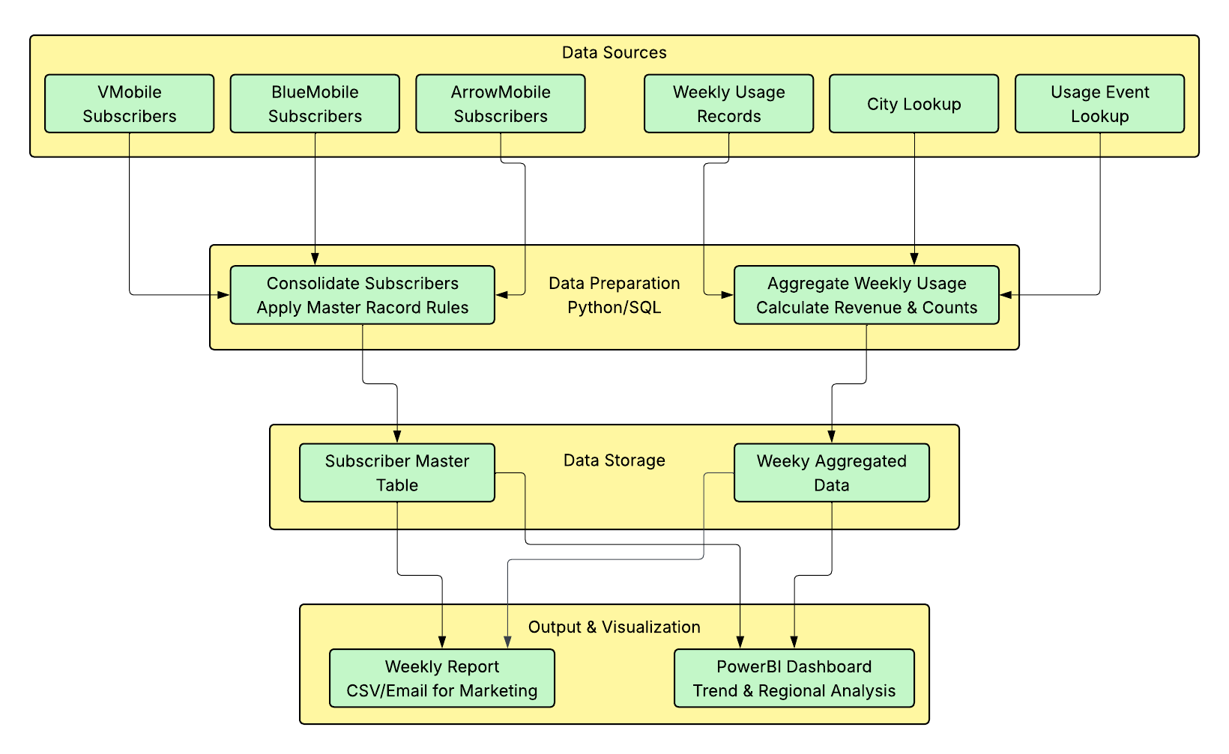

Data Preparation
Creating extensive SQL and Python scripts to combine and integrate subscriber data from three different source systems V Mobile, BlueMobile, and ArrowMobile was part of the data preparation process. Individual tables from each source system were then extracted; these tables had different schemas and data formats that needed to be standardized. Following the merging of these disparate datasets into a single combined subscriber data table, advanced business rules were implemented to identify master records using a hierarchical logic that prioritized V Mobile as the primary source, followed by the most recent SIM activation date, with BlueMobile breaking ties before ArrowMobile. The final output produced a deduplicated master records table containing 401 unique subscribers, alongside a comprehensive qualifying subscriber table that identified 359 subscribers meeting the R30 weekly revenue threshold, establishing a clean, reliable foundation for all subsequent analysis and reporting.

Data Visualisation
The following visualisations will be created.
- Executive Summary Dashboard: this dashboard, which includes four major KPI cards that display qualified subscribers, revenue, qualification rate, and average revenue per qualifier, gives senior management a high-level overview of campaign performance. It features a top regions bar chart that highlights regional performance as well as a weekly trend line chart to monitor performance over time. The key "what happened" narrative of campaign efficacy is presented in a clear, executive-friendly form that facilitates rapid strategic decision-making, and an interactive week selection allows filtering all visuals.

- Regional Performance: this dashboard, which was created for regional managers, emphasizes geographic insights by displaying subscriber distribution and performance by location on a map. A province comparison bar chart, a revenue distribution donut chart, and a comprehensive regional performance table with sortable columns and conditional formatting are all included. With the help of interactive filtering offered by dual slicers for week and province, regional teams may compare performance across regions, spot geographic trends, and improve specialized marketing tactics.

- Dashboard of Subscriber Insights: with features like a revenue distribution histogram with the R30 qualification threshold, a usage pattern scatter plot comparing SMS vs. voice call behaviour, and an extensive subscriber table with filtering capabilities, this analytical dashboard offers marketing analysts deep subscriber behaviour analysis. Demographic breakdowns show source system distribution and age groups, while an interactive filter panel allows segmentation by region, qualification status, and revenue range, enabling detailed subscriber segmentation and behaviour pattern analysis.

- Weekly Operations Dashboard: this dashboard, which was created for everyday marketing operations, offers actionable data along with a thorough list of qualified subscribers, weekly performance comparison KPIs that display changes from week to week, and performance alarm indications that use a traffic light system. It is the useful tool for weekly campaign management and operational decision-making since it offers at-a-glance performance metrics through a regional fast view matrix and allows for instant action on campaign follow-ups through an export panel.

Client Presentation
The client presentation will tell a compelling story of transforming V Mobile's campaign visibility challenges into data-driven success. It begins with the business problem of lacking campaign performance insights, then demonstrates the technical solution through an automated data pipeline. The presentation showcases key findings including 359 qualified subscribers generating R97,521 revenue, with deep dives into geographic and behavioural insights. A live dashboard demonstration highlights the interactive capabilities, followed by business impact analysis showing 80% reduction in manual reporting time. The presentation concludes with implementation details and a clear path forward for ongoing data-driven marketing optimization.

Technology
The following technology was used for each stage of the project.

 | Data  Analysis | Data Preparation | Data Visualisation | Client  Presentation
PostgreSQL Server | X | X
Python | X | X
PowerBI |  |  | X
PowerQuery |  | X | X
Excel | X | X
PowerPoint |  |  |  | X
Lucidchart | X

